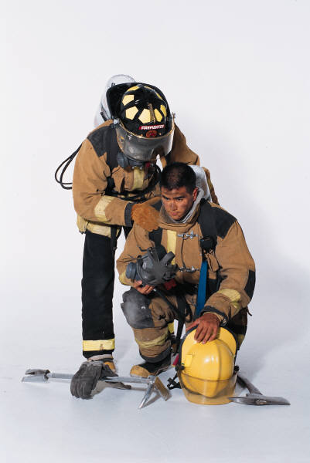

|  |
| --- |
| **Volunteer & Exempt Firemen’s Benevolent Association of Lynbrook** |
| **Financial Statement & Supporting Documentation** |
| **Confidential Information** |

C:\Documents and Settings\ED\Local Settings\Temporary Internet Files\Content.IE5\0JQLMEWA\MC900188055[1].wmf

# Instructions

1. Provide as much information as possible (more information is better than less).

* Current pay stubs (yourself & spouse)
* Current bank statements (all accounts – checking, savings, cd’s, retirement, etc.)

1. Include copy of your latest Federal 1040 Tax Return.
2. Include all documentation for your 1040 return (W2 etc.).
3. If you are married, please supply information for yourself and your spouse.
4. Indicate what the most important items in arrears are.
5. The Credit Card information is for information purposes only, we do not usually consider credit cards for payment.
6. Indicate what steps you have taken to try and improve your financial situation (increase income – reduce expenses etc., seek outside financial counseling).
7. What has changed to cause you to have a financial problem? (i.e. Unemployment etc.)
8. Do you see any positive changes in your situation in the coming months (new job – etc)?
9. It is important that you confer with the Trustees from your Company as to the information that is necessary for this statement.
10. If assistance is granted – part of the member’s responsibility is to provide

copies of your payments for the items covered by the Benevolent. This documentation ***MUST*** be received within 30 days of the assistance being granted. If not received, a fine will be imposed by the board.

The Trustees Meeting is the Fourth Monday of each month

# Information Page

# Information Page

